No. DIT&C/EST/SDC-62/2013(Vol.II)(Pt.) Kohima Dated 23rd November 2023
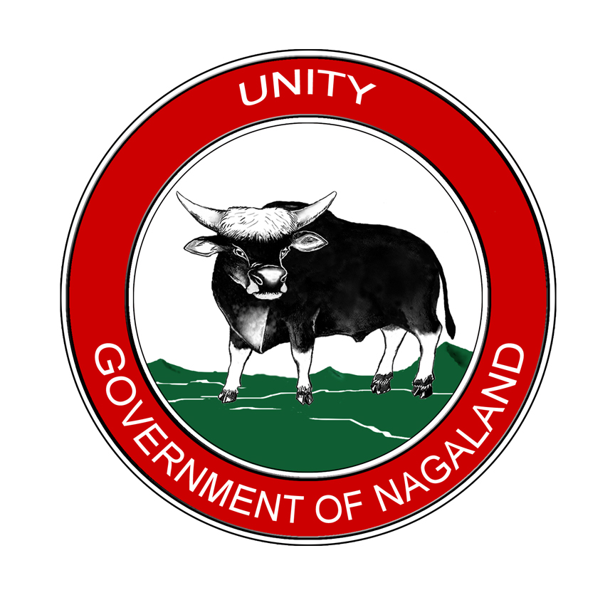

NOTICE INVITING TENDER

The Directorate of IT & Communication invites tender for Software Management and Delivery and Installation of IT Equipment for Existing Nagaland State Data Centre (NSDC) of Government of Nagaland.
The detailed tender documents can be viewed / downloaded from the following website, from 24th November 2023 to 12th December 2023:
- www.nagalandtenders.gov.in
- www.nagaland.gov.in

Amendments/Corrigendum, if any will be hosted on the above website.

Sd/-

Er. Sabou Yashu
Director, IT&C

